**Online course selection system**

The online course selection system of a school mainly includes the following functions:

The administrator enters through the system management interface, establishes various courses to be held this semester, saves the course information in the database, and can modify and delete the courses. Through the client browser, students can enter the course selection interface according to their student id and password. Here, students can conduct two operations: inquiring the selected courses and selecting courses. Again, through the business layer, the results of these operations are stored in the database.

**Modeling**

Actor: Registar, Student, People(Abstract), Database

Use cases: Select Course, Query Course, Add Course, Modify course, Delete Course

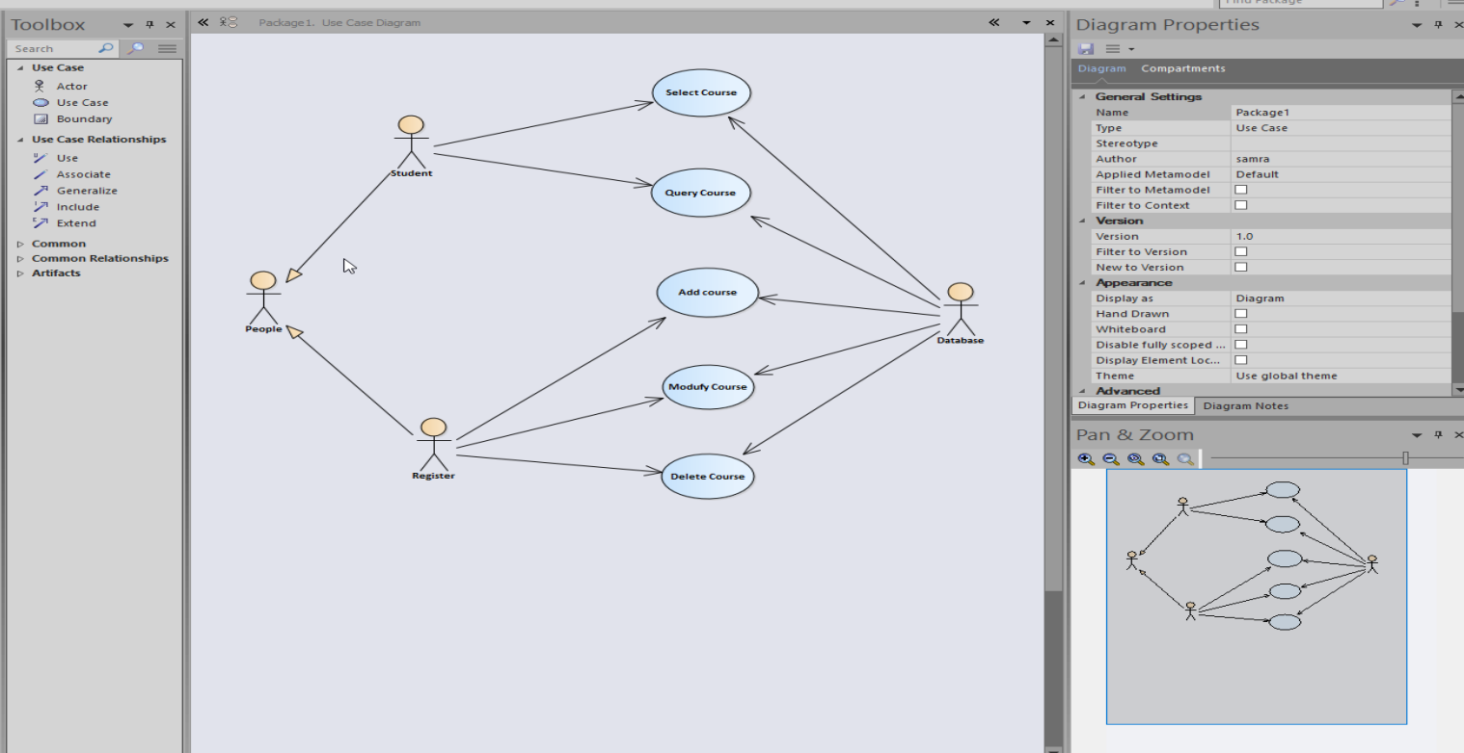

**Add the course event stream**

(1) The administrator selects to enter the management interface and the use case starts

(2) The system prompts for the administrator password

(3) The administrator enters the password

(4) System verification password

A1:

Wrong password

(5) Enter the management interface and the system displays all the course information currently established

(6) The administrator chooses to add courses

(7) The system prompts for new course information

(8) The administrator enters the information

9) The system verifies whether it is in conflict with existing courses

A2:

there are conflicts

(10) The system adds new courses to prompt the success of the courses

(11) The system reenters the main management interface to display all courses

(12) ends with a column

**Other event flow**

A1: Wrong password

(1) The system prompts you to input again

(2) User confirmation

(3) Three times error, refused to visit again

(4) otherwise

Add the course event stream

(1) The administrator selects to enter the management interface and the use case starts

(2) The system prompts for the administrator password

(3) The administrator enters the password

(4) System verification password

A1: Wrong password

(5) Enter the management interface and the system displays all the course information currently established

(6) The administrator chooses to add courses

(7) The system prompts for new course information

(8) The administrator enters the information

9) The system verifies whether it is in conflict with existing courses

A2: there are conflicts

(10) The system adds new courses to prompt the success of the courses

(11) The system reenters the main management interface to display all courses

(12) ends with a column

**Error stream**

A1: Verification failed

(1) The system prompts verification failure, prompting re-input (2) Three times of failure, access is denied

(3) Successful transfer of course events (5)

A2: Courses are not optional

(1) The system prompt course is not available and the reasons

(2) Students reschedule their courses

(3) Course transfer event flow (10)

**Activity Diagram**

Take the Add Course use case as an example.

(1) The administrator enters information

(2) Whether the system is in conflict with existing courses

A2:

there are conflicts

(3) New courses are added to the system to prompt for successful addition of courses. (4) The system re-enters the main management interface to display all courses

(5) End with a column

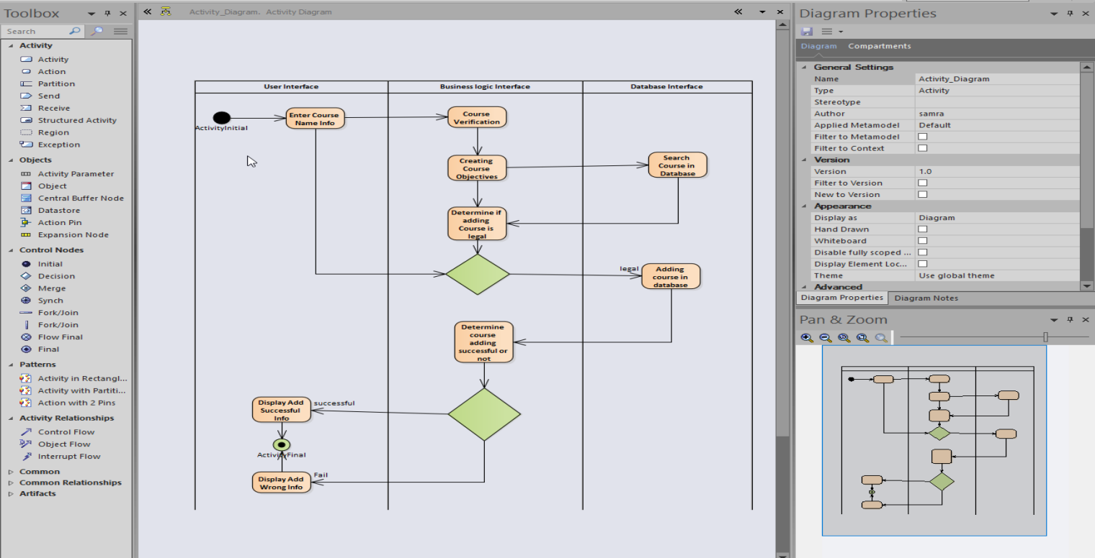。

**object**

(2) Look for roles

Objects: Interface, Course , business layer control object role: student, database

**Select Course use case interaction sequence**

(1) Students send course selection commands through the interface

2) Bounded control-oriented object requests course information

3) The control object sends query data information to the database

4) Control the query results of the temporary database

(5) The interface object obtains all course information from the control object

6) Display all course information on the interface

(7) The interface object sends commands that require the control object to delete the course information

(8) Students choose courses

9) The interface object requires students to input their student number

(10). The interface sends information to the control object to inquire whether the student can choose a specific course

(11) The control object queries association information from the database

(12) The control object judges whether the course can be selected

(13) If courses can be selected, the associated information will be added to the database.

(14) Return information to the interface object.

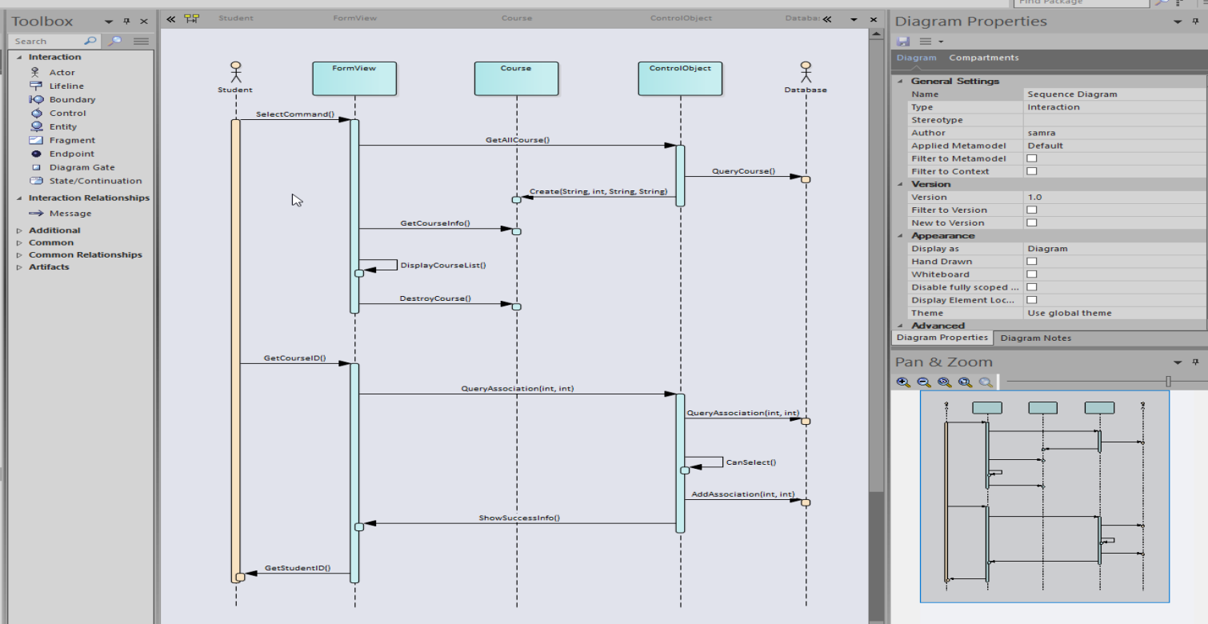.

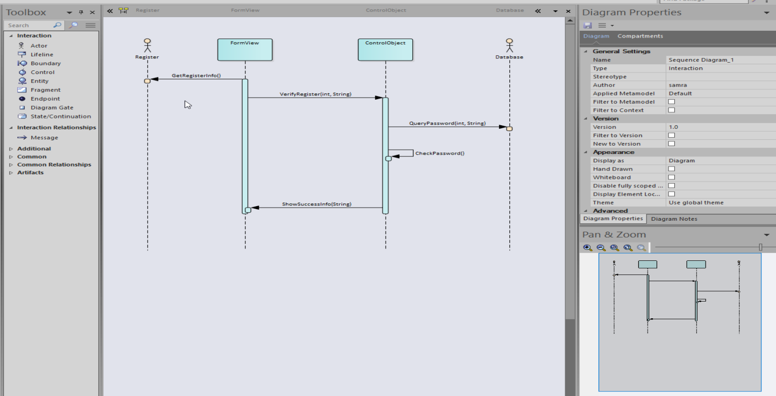.

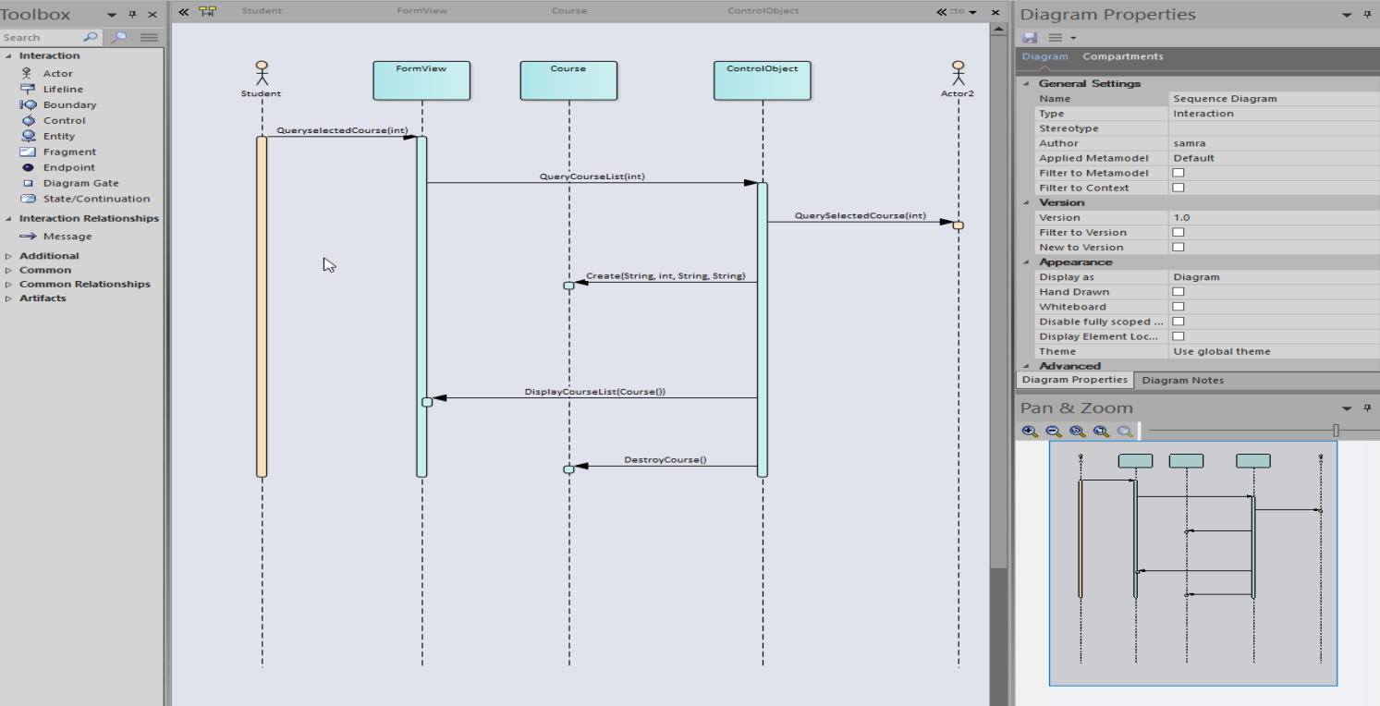.

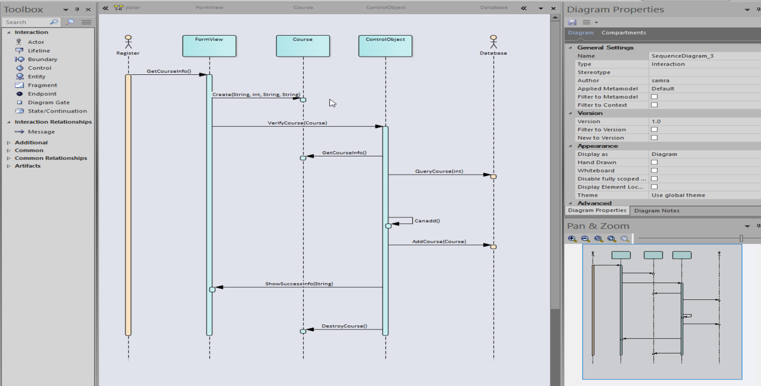

**The class diagram**

Entity Class: Course

Boundary class: Interface class: FormView

Control class: ControlObject class ControlObject

Roles: Student, Registar, People (parent) Database

Relationship: When students and administrators interact with the system, there is an interface corresponding to it, which may be related to multiple courses. The control object is responsible for course processing, and the processing results are displayed on the street. The control object completes the operation of the database, and the interface requests the service of the control object

**Class- People**

Name String

Age int

GetName()

SetName()

Getage()

SetAge()

**Class- Student**

StudentId int

Student()

GetStudentID()

SetStudentID()

